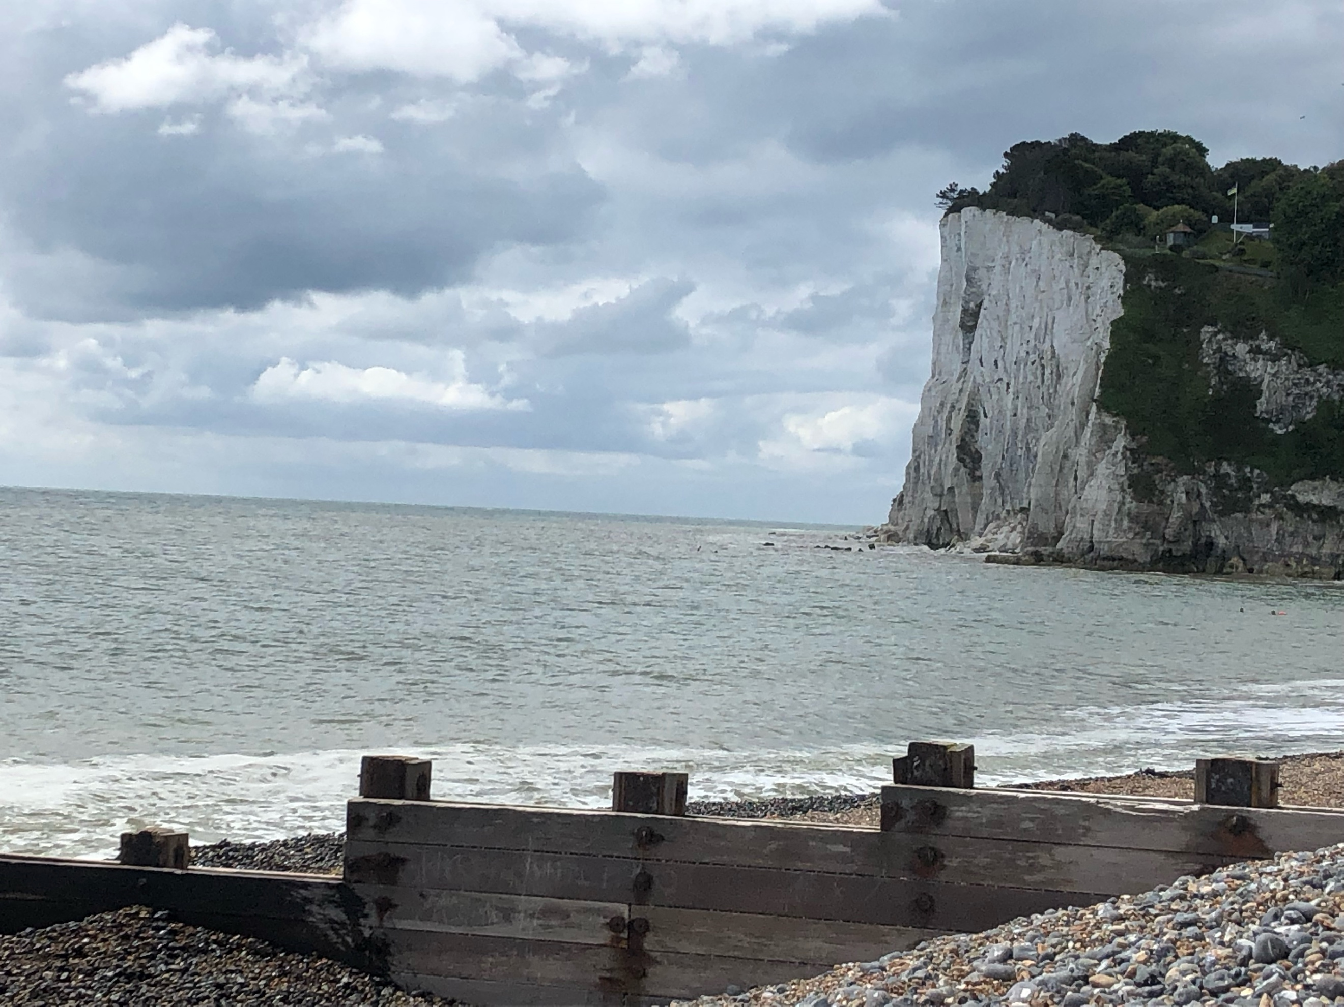  Community grants  St Margaret’s at Cliffe Parish Council | Policy on Grants under Section 137 of the Local Government Act 1972.

Table of Contents
1. Introduction 2
2. Who is eligible to apply? 2
3. What can be funded? 2
4. The following cannot be funded 2
5. Obligations 2

Date of policy | 12th November 2024
Approving committee | St Margaret’s at Cliffe Parish Council
Date of committee meeting | 8th December 2025
Supersedes | March 2023
Policy effective from | March 2023
Date for next review | December 2026

Introduction
In accordance with the Local Government Act 1972 section 137, St Margaret’s at Cliffe Parish Council sets aside a sum of money each year which can be applied for by local organisations for projects which will be of benefit to residents within the parish.
To ensure that the council’s grant budget can be distributed to as many community projects and activities as possible, it is unlikely that the council will consider approving grants above £750. However, the council understands there may be extenuating circumstances for which a higher amount may be requested, and this will be given due consideration at the time

Who is eligible to apply?
The Parish Council’s awards are open to established voluntary or community groups. In fact, the council encourages applications from groups of residents, who are undertaking an activity to support residents of the local community.

What can be funded?
Initiatives which make the local community a better place in which to live, work or visit and benefit people who live in the parish. The parish council must be satisfied local people support the project and are involved in carrying it out.

The following cannot be funded
Support for individuals or private business projects, including those which may benefit / improve privately owned property/land. Applications cannot be retrospectively submitted for projects which have already been completed.

Obligations
Successful applicants will be required to provide feedback on their usage of the grant either at a Parish Council meeting or for inclusion in the Village Magazine, and/or Social Media Platforms.
Name of Organisation
Contact Name
Address
Telephone
Email
Aims and objectives of your organisation. Provide a copy of your constitution if you have one.
Date organisation was established

Do you have a bank account into which we can pay your grant?
Please circle the Income, Expenditure and Balances* category which applies to your organisation
Income | <£3,000 | <£10,000 | <£20,000 |  | >£20,000
Expenditure | >£3,000 | >£10,000 | >£20,000 |  | >£50,000
Balances | <£1,500 | <£3,000 | <£5,000 |  | >£5,000
Please include copies of the bank statements covering the previous six months. If you are unable to do this, please provide your reason why below.

*Balances are defined as monies readily available for day to day running of your organisation

Please select the type or organisation you are and if a registered company or charity please supply registered number.
Registered Company | Charity | Other | Please define other:
Please supply a complete copy of the latest set of annual accounts/return showing the income, expenditure, and level of balances. If you are unable to do this, please provide your reason why below.

For what purpose or project is the grant requested?
Signed
Date
Role within organisation
For Parish Council Use Only
Approved | ☐ | Not Approved | ☐
Notes:
Please use this page for any additional notes which won’t fit on the from above:

